## **Objectives**

* Explain branching and merging
* Explain about creating a branch request in GitLab
* Explain about creating a merge request in GitLab

In this hands-on lab, you will learn how to:

* Construct a branch, do some changes in the branch, and merge it with master (or trunk)

## **Prerequisites**

The following are the pre-requisites to complete this hands-on lab:

* Setting up Git environment with P4Merge tool for Windows

**Output(Branching):**

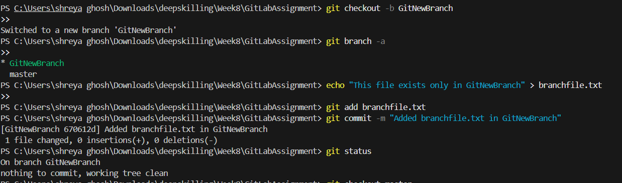

**Output(Merging):**

